Program structure:  
There is the main entrance of the program under the program.cs

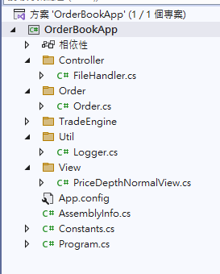  
  
  
Configuration:

The input files and output files are now configured as the 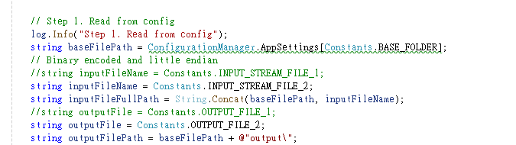

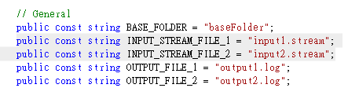

**Program execution:**  
By execute the “.\OrderBookApp.exe 5”  


The price depth will be generated at console and output folder .

